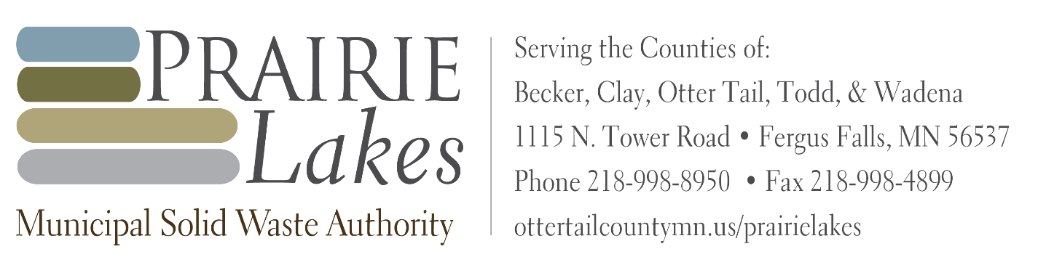

MEETING NOTICE

Date: October 31, 2025

Event: District 4 Meeting

Location: Otter Tail County Government Service Center, 500 W Fir Ave, Fergus Falls, MN 56537

To: Prairie Lakes Municipal Solid Waste Authority (PLMSWA) Board Attending

MEMBERS ALTERNATE MEMBERS
Phil Hansen (Becker) | Richard Vareberg (Becker)
Kevin Campbell (Clay) | Jenny Mongeau (Clay)
Dan Bucholz (Otter Tail) | Wayne Johnson (Otter Tail)
Sean Sullivan (Otter Tail)
Tim Denny (Todd) | Randy Neumann (Todd)
Bill Stearns (Wadena) | Murlyn Kreklau (Wadena)

To Be Announced

