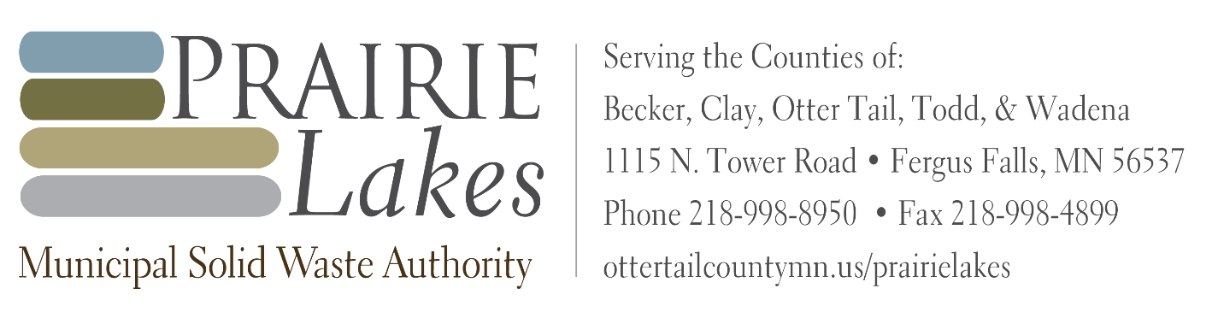

MEETING NOTICE

Date: December 8 to December 10, 2025

Event: AMC Annual Conference Workshop

Location: Double Tree Hotel Bloomington, 7800 Normandale Blvd, Minneapolis, MN 55439

To: Prairie Lakes Municipal Solid Waste Authority (PLMSWA) Board Attending

MEMBERS ALTERNATE MEMBERS
Phil Hansen (Becker) | Richard Vareberg (Becker)
Kevin Campbell (Clay) | Jenny Mongeau (Clay)
Dan Bucholz (Otter Tail) | Wayne Johnson (Otter Tail)
Sean Sullivan (Otter Tail)
Tim Denny (Todd) | Randy Neumann (Todd)
Bill Stearns (Wadena) | Murlyn Kreklau (Wadena)

To Be Announced

